HOLY TRINITY COLLEGE

ATTENDANCE POLICY



Mission Statement

As a Catholic school, Holy Trinity College provides quality teaching and learning, in a respectful, inclusive, and nurturing environment. We are committed to ensuring pupils achieve their potential, experience success, and contribute meaningfully to an ever-changing society.

High Expectations Tolerance & Inclusion Collaboration for Success

(Revised: June 2025)
School Attendance Policy

Attend today: Achieve tomorrow

Rationale:
The Department of Education document ‘Miss School = Miss Out Improving Pupil Attendance Strategy (Dec ’16) highlights ‘Attending School regularly is important for all pupils because of how their attendance can affect their educational attainment and their subsequent life chances.’
The Governors and staff of Holy Trinity College are committed to providing a full and effective education for all our pupils to ensure they achieve their full potential. We work together to encourage in our pupils positive attitudes and we promote an ethos and culture which encourages good attendance and where each pupil will feel valued and secure. Academic success in school is interdependent with good attendance and pupils will achieve their full potential and be happy members of the school community if they attend school each day.
The Department of Education document ‘School Attendance Matters A Parent’s Guide’ highlights ‘Young people who regularly miss school without good reason are more likely to become isolated from their friends, to underachieve in examinations and/or become involved in anti-social behaviour.’
Pupils, parents and teachers work together to maintain high standards of attendance. Our school aims to achieve good attendance by operating an Attendance Policy within which staff, pupils, parents and the Education Welfare Service can work together in partnership. All staff will encourage punctuality and good attendance.

DE’s Policy for School Improvement ‘Every School a Good School’ April 2009; states that every school should ensure that ‘…a culture of achievement, improvement and ambition exists – with clear expectations that all pupils can and will achieve to the very best of their ability’. This policy emphasises the important link between good attendance and academic success.
The Department of Education document ‘School Attendance Matters A Parent’s Guide’ highlights
‘Excellent attendance at school is important to allow a child or young person to fulfill their potential.’
All staff have responsibility for pupil attendance in school.

Aims:
In Holy Trinity College, we aim to foster positive attitudes towards education and encourage pupils to value the importance of good attendance and punctuality.
To improve the overall attendance of pupils in Holy Trinity;
- To promote good attendance through positive home school relationships;
- To develop a framework that defines roles and responsibilities in relation to attendance;
- To recognise good attendance with awards, postcards of congratulation and certificates;
- To provide advice, support and guidance to parents/guardians and pupils;
- To promote and develop effective working relationships with the Education Welfare Service.

The School’s Expectations on Attendance:

To ensure regular attendance and punctuality, Holy Trinity College has the following expectations from pupils and parents

Role of Pupil
Every pupil has a duty to ensure that she attends school every day and is punctual.
- To be in school each day and to be on time – 8.45 a.m.
- To attend all classes required by her timetable
- To never leave school during the day without permission
- To keep a record of attendance in her Homework Diary
- To bring in a note from her parent/guardian on the day of her return explaining the period of absence
- To catch up on all work missed during her absence

If a pupil falls ill during the school day, he/she must report to the School Nurse who will contact the parent/guardian where necessary.

Role of Parent/Guardian

Parents have a legal duty to ensure: Every child of a compulsory school age shall receive efficient full-time education suitable to age, ability and aptitude and to any special educational needs he may have, either by regular school attendance or otherwise.
(Education and Libraries (Northern Ireland) Order 1986)

The staff of Holy Trinity College is committed to working with parents to encourage regular and punctual attendance and

- To value the importance of a good education
- To support the school's policy regarding attendance, non-attendance and punctuality
- To ensure that their child is in school every day and are on time
- To contact the school before 9am if their child are going to be absent
- Provide a signed note explaining any absence on the day of their child’s return
- To provide information to the school if their daughter will be absent for a prolonged period of time
- To collect work from the school or encourage their child to access work via Google Classroom if he/she is off for a prolonged period of time
- To take holidays during holiday time and not to book family holidays during term time
- To arrange dental/medical appointments out of school time
- To contact the Head of Year, Head of Key Stage or Vice Principal if their child is reluctant to attend school to ensure that both the parent and child receive maximum support.

Role of the School

To enable our school to record and monitor attendance in a consistent way we will adhere to the guidance of the Department of Education.

- The Board of Governors provides support by reviewing school attendance and targets and ensures that it is placed as an agenda item at meetings on a regular basis;
- Set attendance targets in accordance with the School’s Development Plan
- Record and monitor attendance and punctuality in a consistent way in line with DE guidance (Department of Education Circular 2013/13)
- At Senior Leader Team meetings, review Year Group attendance percentages.
- Introduction of Truancy Call, an automated system used to contact parents to inform them of their son or daughter’s absence if they have not informed the school by 9am in the morning. (June 2017)
- To develop strategies to encourage good attendance
- To use sanctions which will deter absences and truancy
- To check attendance every lesson
- To monitor attendance and punctuality
- To use positive incentives to encourage pupils to improve/maintain good attendance
- To work as a team with Parents, the Education Welfare Officer, Form Teachers, Heads of Year, Head of Key Stage and the Vice Principal
- In Key Stage 3, send letters of concern to parents at Halloween and February. (In Key Stage 4 and 5 attendance concerns are communicated through the Interim Reports.) – See Appendix 1&2. Form Teachers are asked to sign the letters and return them for posting. They are in the best position to withdraw any letter of a pupil where they are aware of the legitimate explanation for absence.
- Where attendance of a pupil does not improve, the form teacher should bring this to the attention of the Head of Year who will contact the parent to discuss attendance concern and to inform of a referral to the EWO.
- To interview individual pupils/parents regarding attendance when and where necessary.
- To ensure the EWO has access to school attendance data and alert her in the case of on-going absences
- To issue a suspension for leaving school without permission.
- To maintain a record of requests for time out of school for appointments and to make frequent checks – All requests to be processed through the Head of Year.
- To provide work for the pupil if she will be off for a prolonged period of time by liaising with the staff to provide either hard copies or work via GC. – the parents must inform the school of the reason for this absence and be in apposition to collect the work from school
- To provide information on request for a pupil's attendance record to employers and other educational establishments.

Role of the Education and Welfare Officer

It is the responsibility of the Education and Welfare Officer to:
- Develop an effective partnership with the school in dealing with pupil welfare/attendance.
- Actively promote good attendance and punctuality in the school.
- Monitor the attendance of pupils.
- Liaise with the Head of Year in matters of pupil welfare and attendance.
- Provide accurate information on individual attendance as required by the school/outside agencies

Education Welfare Service

Education and Library Boards through the Education Welfare Service have a legal responsibility to make sure that parents meet their responsibility towards their child’s education. Regular attendance is an essential requirement for educational results and where attendance difficulties exist or a pupil’s attendance falls below 85%, Education Welfare Service (EWS) will support staff and parents in developing and implementing strategies to address or improve school attendance.

Monitoring Pupil Attendance - Lesson Monitor

Staff monitor lesson attendance through the use of the computerised SIMS system ‘Lesson Monitor’. This programme allows each class teacher to mark the attendance register at the beginning of each lesson a Coding System.
Through Lesson Monitor, teachers can check pupils’ attendance from the previous lessons. If a pupil is absent from the current lesson, without a valid reason, the teacher will email the pupil’s Form Teacher or Head of Year. The class teacher will record an N code in Lesson Monitor. The Form Teacher or Head of Year will follow up on the absence.
A pupil should only be absent from class if the reason is authorised. An authorised absence will be indicated by a comment on Lesson Monitor. Authorised absences are recorded as a morning or afternoon and include acceptable reasons such as illness, bereavement, attendance at a medical or dental appointment.
Unauthorised absences are those which the school does not consider reasonable and for which no permission has been given. These include:
- Truancy
- Shopping
- Baby Sitting
- Absences which have not been properly explained
The office Staff will record an S code (Study Leave) in Lesson Monitor for pupils who are doing Public Examinations in Years 12, 13 and 14 during the examination period. Study Leave (Code S) will not be used for internal examinations or in advance of the commencement of the examination timetable.

Positive Measures to Encourage Good Attendance

The pastoral structure within the school places a high priority on the integration of the pastoral and the academic. The focus is on learning so that good attendance and behavior are expected, rather than taught, with expectations being high.

- Class registers will be completed accurately by staff at the beginning of each lesson
- From September 2023, we will increase the profile of attendance at whole school level through communication with parents, posters, assemblies and reward attendance initiatives – See Appendix 4&5 Certificate of Attendance
- Introduction of signage with our top-achieving pupils at GCSE and A Level with their respective percentage attendance figure.
- Form Teachers will monitor pupil’s attendance through Lesson Monitor
- Attendance will be closely monitored by Heads of Year and Key Stage
- Points will be allocated in the Behaviour module in SIMS for full monthly attendance (See the Promoting Positive Behaviour Policy)
- Good attendance is also rewarded and celebrated through monthly or termly rewards at assemblies and photographs shared on the school website. Rewards will include for pupils in Key Stage 3 ‘Passes for immediate entry into the canteen’, in Key Stage 4, a draw for all pupils who have achieved 100% attendance going to Todds Leap and in Key Stage 5, ‘Out of School for Lunch Passes.’ (September 2017)
- Present visually monthly attendance bar-charts for each class for the Pastoral Notice-Boards (September 2023)
- Send an attendance flyer home at the start of every year highlighting the importance of good attendance and linking good attendance with attainment. Make flyers available at the PTM.
- After the third day of a pupil’s absence, if there has been no explanation for the absence from the parent/guardian, form teachers will contact the home to discuss the child’s absence and to heighten awareness of good attendance.
- A review meeting is carried out with the Head of Year and EWO if attendance falls between 85% and 90%
- Regular reviews are carried out and meetings with parents are arranged where necessary
- A very good attendance record will merit a positive and supportive reference to future employers and other educational establishments.
- The School Council, previously elected in 23-24, and in place for 24-25 will drive an EA Programme to support and improve good attendance – the HERO Initiative – Here in school, Everyday, Ready to learn and On time

Punctuality/Lateness

Holy Trinity College places a great deal of importance on the need for all pupils to be punctual and to arrive in school on time. It makes for a good start to the school day and does not interrupt the learning and teaching in the classroom. Poor punctuality has an impact on all other learners as the teacher is required to recap on missing learning for those who arrive late. This reduces learning time for the rest of the class.
Any pupil who arrives late to school and before 8.55am must immediately go to their Form Teacher to get registered as late. This will be recorded as a code L in Lesson Monitor. Pupils who arrive between 8.55am – 9.20am, should present to Principal’s Secretary’s office to be signed in late and recorded as a code L in Lesson Monitor. Pupils who arrive to school after 9.20am should present to General Reception to be signed in late and recorded as a code L in Lesson monitor.

Form Teachers, who notice patterns of lateness to school, should communicate their concerns with parents/guardians regarding punctuality with the standard text: sent via parentapp.

Dear ____________
In the last week/month, ___________ arrived late to school on ________ occasions. __________ offered no explanation for the poor punctuality. Being late to school means that ___________ misses important morning announcements as well as missing the teaching and learning of Period one. I would appreciate it if you can discuss these concerns with _______________.

Thank you
____________________________

If there is no improvement in patterns of punctuality despite this communication, the Form Teacher should refer this concern to the Head of Year, who will discuss the matter with the pupil and issue the Punctuality letter to the parents/guardians – see Appendix 3. All written communications with home should be attached to a pupil’s linked documents.

Responding To Non-Attendance and Lateness
- If no phone call is received from a parent explaining an absence the automated ‘Truancy Call’ will be activated and will continue contacting the parents until the text is answered or a parent phones the school.
- In cases of continued non-attendance or lateness the Education Welfare Officer will be alerted by the Year Tutor and home visits will follow.

ParentApp

Parents can monitor their child’s attendance to school daily and weekly through the ParentApp.

Appointments

Dental and medical appointments should be made after school hours. In an emergency only, a pupil may be granted permission by the Year Head to visit the doctor or dentist. Orthodontist appointments are permitted. In all cases, an appointment card and note (in pupil’s Planner) requesting permission to leave, must be signed by the Head of Year. Parent/Guardian must collect the pupil and be responsible for him/her while he/she is off the school premises. The Parent/Guardian pupil must sign their child out at the Office and sign them in immediately on return to school. Pupils should remain in the classroom until the office staff notifies their teacher that the parent/guardian has arrived to collect him/her/them.
The parents of pupils in Key Stage 5 only, may request permission for their son/daughter to leave school to attend an appointment by emailing our admin. team at alitter489@c2kni.net. The email permission must be sent from the parent’s email address registered on SIMs and the email should contain
- the pupil’s full name,
- the pupil’s date of birth and
- the time that he/she will leave school and, where applicable, the time of return.

(Parents/guardians should ensure that their email address is password secure.)

By emailing this permission, the parent/guardian are providing us with written confirmation that they are assuming responsibility for their son/daughter when they are off our premises.

The email will be shared with the Form Teacher, Head of Year and the Head of Key Stage and the pupil must sign out/in at the front desk as usual.

Parents should not request permission for their son/daughter to be excused from school for any other reason other than to attend an appointment.

For safety and security reasons

Telephone requests – In order to safeguard our pupils, pupils should not ask their parents to ring in to request that their son/daughter may leave school.

Parental Request for a Family Holiday During Term-Time

Parents are requested NOT to book a family holiday during term-time. It is recognised that the pupil’s learning would be disrupted and it can result in her falling behind in her studies.
Family holidays during term-time can only be granted in exceptional circumstances:
- The holiday is important for the well-being and cohesion of the family unit following a serious or terminal illness, bereavement or other traumatic event
- All requests for a holiday during term-time must be submitted in writing to the Principal.
It is our policy that it is not possible to provide the pupil with work during the period she will be on holiday. However, on the pupil’s return to school, teachers will provide them with the work that they have missed. The pupil will be encouraged to work hard and to complete the additional work at home.

We adopt an ‘Every Day Counts’ Policy in school. A summary of the policy is provided below:

‘EVERY DAY COUNTS’

We reinforce ‘Every Day Counts’ to promote good attendance.
If a pupil fails to attend school regularly, the following steps will be taken:

Step One: An absence generates a daily automated phone call from ‘Truancy Call’.

Step Two: Form Teachers/Head of Year will contact parents to enquire about prolonged
/irregular unexplained absences.

Step Three: The Head of Year will liaise with parents, pupils and the Educational Welfare Officer, At the end of each term the parents/guardians of pupils with an attendance of between 85% and 90% will be contacted by the Head of Key Stage.

Step Four: If a pupil’s percentage attendance is 85% or below, the Education Welfare Officer will contact the parents/guardians.

90% attendance sounds good and most parents would be very pleased
if their daughter achieved this in a test.
However it means missing one whole day of school every fortnight.

Related School Policies:
This policy is set within the broader school context of Pastoral Care and as such should be implemented in conjunction with the following school policies:
- Pastoral Care Policy
- Child Protection Policy
- Positive Bahaviour for Learning Policy
- SEN Policy

Monitoring, Evaluation and Review:
The VP and Heads of Key Stage are responsible for monitoring, evaluating and reviewing the implementation of The Attendance Policy. The VP will revise the policy and procedures in light of any further DE guidance and legislation as necessary and review it annually. This will be done in consultation with governors, staff, pupils, parents and the Education Welfare Service. On-going evaluation will ensure the effectiveness of this policy.

Next Review Date: September 2026
Appendix 1

(Today’s date)

Mr and Mrs M Pack
(Address)

Mark Pack 8KLE

Dear Mr and Mrs Pack

Your son Mark has a low percentage attendance.

His percentage attendance to date is 70.97% and this is a cause for concern.

Mark’s total absences are shown below:

Total Authorised Absences 7
Total Unauthorised Absences 2

I would be grateful if you would contact the College as soon as possible.

Thank you for your co-operation.

Yours sincerely

Mr M. McGurk
Form Teacher

Appendix 2

FT Letter 01/09/2023 – 23/10/2023

(Today’s Date)

Mr and Mrs S Pense
Address

Mark Pence 10TOR

Dear Mr and Mrs Pence

I am writing to inform you that the attendance of your child Mark has not met the minimum percentage expected by the school during the period shown below.

The following is a record of Mark’s percentage attendance this year to date: 77.78 %

The minimum percentage expected by the school is 95%.

Poor attendance at school can seriously affect progress and we would therefore appreciate your full co-operation and support in addressing this matter from now on.

If attendance drops below 85% it is my legal obligation to inform an Education Welfare Officer. Mark’s case was discussed at my last meeting with Education Welfare Officer. It will be necessary for me to complete this referral if Mark’s attendance does not improve.

You may have provided explanations for absence to the school, as this is standard procedure; therefore, this letter aims solely to provide you with Mark’s attendance percentage for this period.

Thank you for your co-operation.

Yours sincerely
_____________________

Form Teacher

Appendix 3
Dear Parent/Guardian,

Since the beginning of term, there has been a number of pupils arriving late for school in the morning. This lateness to school and study disrupts a pupil’s own learning and interrupts the learning of others.

The administrative task of marking in ‘latecomers’ impacts directly on the sending of ‘Truancy Call,’ which is an important tool in safe-guarding our pupils.
It has come to my attention that your son/daughter, ______________ has arrived late to school on numerous occasions. Their form-teacher and I have spoken to ________________ about our concerns and we ask for your support in ensuring that _______________ gets up in good time and arrives to school on time with a readiness to learn and work hard.

Thank-you for your continued support
____________________________
(Head of Year)

Appendix 4&5
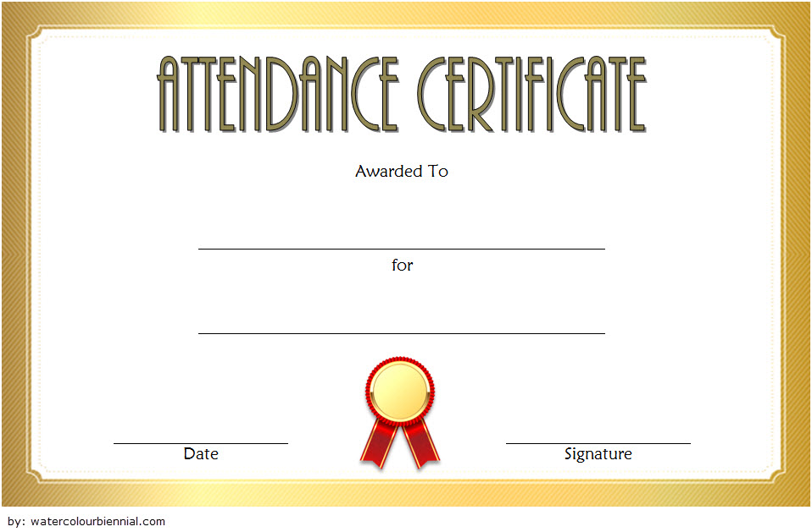
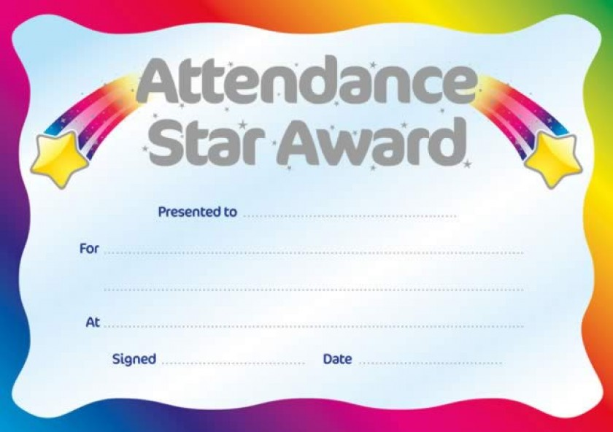

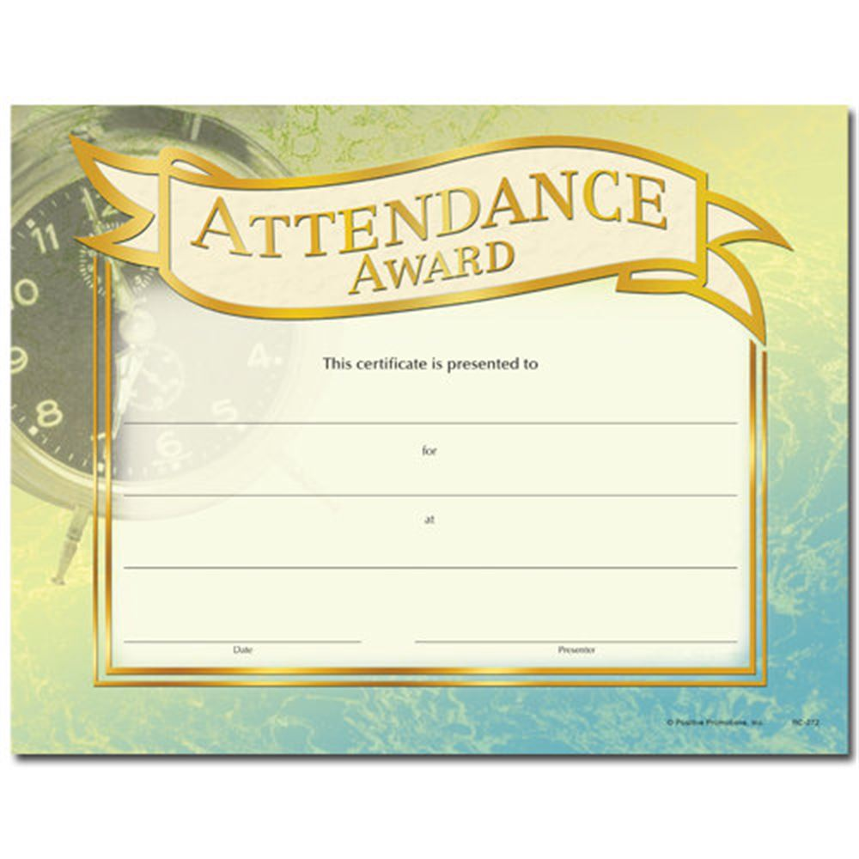


HOLY TRINITY COLLEGE

ATTENDANCE POLICY

Signed ……………………………………………(Chairman of Board of Governors)

Signed …………………………………………….(Principal)

Date ……………………………………..

Board of Governors Meeting held on ………………………………………………………….

Next Review Date: August 2026

