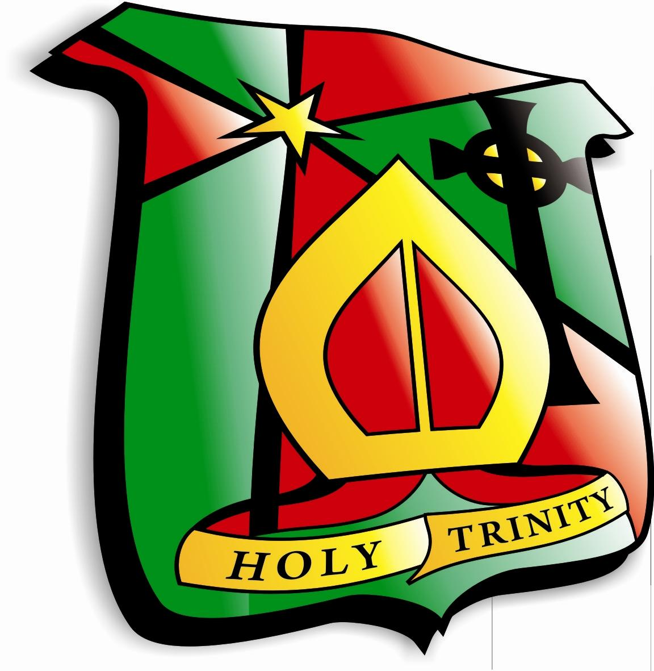
Holy Trinity College

Assignment Schedule
2023-2024

Assessment weeks for Year 12

Assessment Week 1: November 30th-December 8th 2023

Assessment Week 2: February 26th-29th 2024

GCSE EXAMS:
 | Exam  Board | Percentage of course examined in Year 12 | Details  (Controlled Assessment/ Practical/ Exam) | Month of Assessment  September ’23 – June ‘24
Core Subjects
English | CCEA | 60% | 1 exam worth 30%  1 controlled assessment completed in Year 12 worth 10%  3 Speaking and Listening assessments (20%) | CA1 – Assessment week 1  Extended Reading (10%) ‘Of Mice and Men’  Term 1- S&L1- Presenting  (included in marks for Assessment week 1)  Term 2- S&L2- Role-play  (included in marks for Assessment week 2)  Term 3 - S&L3- Group Discussion (included in marks for Assessment week 3)  November Repeat – Unit 1 – 17th November 2023  Unit 4 Exam- 20th November 2023
Maths | CCEA | All classes will complete 55%module  (M6/M7/M8) in June 2023  Pupils will have the opportunity to repeat their 45% module M1,M2,M3,M4) in November 2023. | External Exam Only  A*/A(M4&M8)  A*/A(M4&M7)  B(M3&M7)  B(M3&M6)  C*(M2&M6)  C(M1&M6) | All classes  Repeats November 2023 M1-M4  May/June M6-M8 2024
Further Maths | CCEA | 100%  [Mr O’Boyle’s group only] | External Exam Only | June 2024
 | Exam  Board | Percentage of course examined in Year 12 | Details  (Controlled Assessment/ Practical/ Exam) | Month of Assessment  September ’23 – June ‘24
Religion  OR  Religion | CCEA GCSE  OCN | 50%  N/A | Internal – End of Unit Past paper questions  Internal – End of Unit Past paper questions  Internal – End of Unit Past paper questions  External Exam  Unit 1 & Unit 2 Completed  Unit 3 & Unit 4 Completed  Unit 5 Completed  Unit 6 Completed  9 Pieces of work for Portfolio over 2 years  (No External exam) | October  December  March  May/June 2023  October  December  March  June  May 2023
Single Award Science | CCEA | 75% | Unit 2: Chemistry - 25%  Unit 3: Physics - 25%  Unit 4: Practical skills - Two parts (Booklet A - 7.5% - 2 practical tasks)  (Booklet B - 17.5% - 1 external written exam) | Nov 2023  June 2024  Between 1st Jan & 1st May 2024  June 2024
 | Exam  Board | Percentage of course examined in Year 12 | Details  (Controlled Assessment/ Practical/ Exam) | Month of Assessment  September 23 – June 24
Digital Technology  Level 1/Level 2 First Award in Information  And Creative Technology | CCEA  Edexcel BTEC  Pearson | 70%  75% | 40% - Exam  30% - Controlled Assessment  Controlled Assessment | May/June 2024  Ongoing  Ongoing
Learning for Life and Work (LLW)  LLW | CCEA  OCN | 60%  100% | 20% - Exam  40% - Controlled Assessment: Employability – Employer and Employee responsibilities.  5 pieces of controlled assessment | May/June 2024  Ongoing  On-going
 | Exam  Board | Percentage of course examined in Year 12 | Details  (Controlled Assessment/ Practical/ Exam) | Month of Assessment  September 23 – June 24
Optional Subjects
Art & Design | CCEA | 60%  40% | Component 1:  Part A:  Exploratory Portfolio  Controlled Assessment  Portfolio of experimental work. (25%)  Part B:  Investigating the Creative and Cultural Industries  Personal Outcome or Design Solution (35%)  Component 2:  Externally Set Assessment  Controlled Assessment  Preparatory Work and Final Outcome | A01- Developing Ideas  A02 – Refining Ideas –  Christmas exams: November 30th-December 8th 2023  A03 – Recording Ideas –  Assessment week 2 February 26th-29th 2024
Engineering | CCEA | 75% | Unit 2: Practical Exam 25%  Unit 3: Exam 50% | Unit 2: Exam May/June 2024  Unit 3: Exam May/June 2024
Construction OS | CCEA | 50% | Internal Exam in Summer  Attainment of practical skills for controlled assessment. | May ‘24  Ongoing
Engineering OS | CCEA | 50% | Internal Exam in Summer  Attainment of practical skills for controlled assessment. | May ‘24  Ongoing
 | Exam  Board | Percentage of course examined in Year 12 | Details  (Controlled Assessment/ Practical/ Exam) | Month of Assessment  September 23 – June 24
Double Award Science | CCEA | 67% | Biology unit 2 14%  Chemistry unit 2 14%  Physics unit 2 14%  Practical skills unit 7 (2 parts) :  Booklet A - 7.5%, 3 practical tasks between 1st January- 1st May 2024.  Booklet B – 17.5%, 3 external written exams, June 2024 | June 2024  June 2024  June 2024
Home Economics | CCEA | 100% | Controlled Assessment (50%)  External Exam (50%) | Ongoing  May/June 2024
Contemp Cuisine | CCEA | 50% | Weekly assessments throughout the course. | Ongoing
Child Devel. | CCEA | 70% | Controlled Assessment – 40%  External Exam - 30%  In addition - repeat from year 11 for some students – 30% | Ongoing  May/June 2024
Health and Social Care | CCEA | 50 % | Controlled Assessment – issued 1st November 2023 for completion by May 2024  Key areas:  · Service users  · Provision of Services  · Accessing Services  · Job roles within health service  · Safeguarding  · Values of care | No assessments  Students will be working on Coursework from December – May  Coursework to be submitted will be a complete piece – no omissions this year.
 | Exam  Board | Percentage of course examined in Year 12 | Details  (Controlled Assessment/ Practical/ Exam) | Month of Assessment  September 23 – June 24
Sociology | WJEC Eduqas | 100% | 2x External Exams: worth 50% Each | May/June 2024
Sports Studies | Edexcel | 50% | Unit 1 - Exam: External Component – Fitness for Sport & Exercise  Unit 5 - Controlled Assessment: Training for Personal Fitness | May/June 2024  Ongoing
 | Exam  Board | Percentage of course examined in Year 12 | Details  (Controlled Assessment/ Practical/ Exam) | Month of Assessment  September 23– June 24
GCSE P.E. | CCEA | 100% | 50% - Practical Coursework (based on 4 Sporting Activities with 1 to be Orienteering.)  50% - External Exams  (2 x 1hr 15min exams worth 25% each) | On-going  May/June 2024
Agriculture | Edexcel BTEC | 50% | 4 units over 2 years  Unit 1: Animal Health (External Exam)  Unit 2: Animal Handling (Mr McClean)  Unit 3: Animal Welfare (Miss Cadden)  Unit 4: Animal Housing and Accommodation (Mr Loughran) | Ongoing  Completed in Year 11  Completed in Year 11  September2023-Feb 2024  September 2023- May 2024
 | Exam  Board | Percentage of course examined in Year 12 | Details  (Controlled Assessment/ Practical/ Exam) | Month of Assessment  September 23 – June 24
Business Commun. Systems  (Band 1) | CCEA  GCSE | 25%  35% | Controlled Assessment  Exam | Sept – Dec 2023  May 2024  Repeat Exam: Unit 1 - May 2024
Business  (Band 2) | Pearson  BTEC | 50% | Two coursework units | December 2023-March 2024
Geography | CCEA | 60% | 40% - External Exam - Unit 2 Human Geography.  Living in Our World  20% - Unit 3 - Fieldwork Paper. | May/June 2024
BTEC Travel and Tourism | EdExcel | 50% | Controlled Assessment - Two coursework units.  Unit 3 - The Travel and Tourism Customer Experience.  Unit 4 - International Travel and Tourism Destinations. | September 2023 - May 2024  Unit 1 resit if needed January 2024.
 | Exam  Board | Percentage of course examined in Year 12 | Details  (Controlled Assessment/ Practical/ Exam) | Month of Assessment  September 23 – June 24
Music | CCEA | 100% | Component 1: Performing and Appraising (35%)  Component 2: Composing - Controlled Assessment Unit (30%)  Component 3: Listening and Appraising (35%) | Assessment 1: Performance on chosen instrument  Assessment 2: Practical performance and written theory test  Assessment 3: Controlled Assessment - Composition 1 and 2  Full Course  All pupils will complete a solo and ensemble performance on their chosen instrument.  Two compositions will be completed over the course.  One listening paper will be completed- known and unknown music.
History | CCEA | 40% | CCEA External written exam  1hr45mins | Assessment 1 – Internal Christmas exam  Assessment 2 – Internal Assessment  Assessment 3 – CCEA GCSE Exam May 2024
Media Studies | Edexcel | 50%  2 coursework units worth 25% each | Coursework units internally marked and externally moderated | Unit 3: Digital Moving Image Production  Sept 23- December 23  Unit 5:Digital Publishing Production  Jan 24 - April 24

