HOLY TRINITY COLLEGE

SCHOOL TOILET POLICY

College Mission Statement

“Holy Trinity College is a Catholic Maintained school committed to high quality educational opportunities for each pupil to develop his/her unique talents to the full in a secure, caring environment”

Promoting: Inspiration, Innovation, Excellence

(Revised: May 2022)

School Toilets Policy

Aims:

- To maximise access to pupils’ toilet facilities during the day to promote the health, wellbeing and learning opportunities of all pupils.

- To provide good quality toilet facilities throughout the school.

Rationale:

- The school recognises that well-maintained toilet facilities where pupils feel comfortable and safe and have open access to throughout the school day, are essential for health, wellbeing, and learning.

- We value and respect our pupils and want them to be able to benefit from good provision and practice.

Objectives:

- To ensure that this policy is both accepted and upheld by the whole school community - school management, staff, pupils, governors, parents, caretakers, cleaning and ancillary staff.

- To keep at least one set of toilets open and available to pupils throughout the school day. While pupils can use toilet facilities at break and lunchtimes if they need to, we ensure pupils have access at all times. We recognise that toilet needs are highly individual and do not conform to regimental timetables. We recognise that some pupils only feel comfortable going to the toilet when others are not around and will allow pupils to ask out of class with a toilet pass to use the toilet without adverse comment.

- To ensure the toilet facilities cater for the needs of all pupils and ensure these needs are met in a sensitive, informed and appropriate manner.

- To ensure that all toilet areas have properly maintained supplies at all times of warm and cold water, soap, hand drying facilities and toilet tissue in dispensers, provided at a convenient height.

- To ensure sanitary disposal units in all female cubicles serviced on a regular basis and to provide sanitary dispensers in female toilets. We will also ensure that there is adequate signage, sign-posting pupils to the school nurse for further provision.

- To implement and maintain an effective toilet cleaning, supervision and inspection regime to ensure proper standards of provision and cleanliness, throughout the school day.

- To supervise the toilets at break and lunchtimes.

- To actively seek the views of the whole school community in relation to any concerns about toilet provision and access issues (ensuring a child friendly procedure for pupils to report deficiencies or problems) and to respond seriously to these and deal promptly with any problems highlighted by the pupils. .

- To encourage pupils to respect the toilets and each other via the School Council, in form-teacher discussion times, and for pupils to establish a Pupil Code of Conduct in the toilet área.

- To regularly include toilet management issues in all appropriate School Council, staff, parent and governor meetings.

- To provide indoor social areas to discourage toilets from being used for such purposes.

- To implement and maintain annual reviews of the policy to monitor that it is being adhered to and remains relevant.

- Educational programme about the danger of smoking and using vapes delivered to all year group

Managing anti-social behaviour in the Toilet areas:

In the event of anti-social behaviour in the toilet area which pupils or parents/guardians report as making the facilitaties unwelcoming or unsafe, the Senior Leadership team will

- Organise a rota for the supervision of the facilities
- Reduce the numbers of pupils going into the facilities at the same time.
- Avoid friendship groups using the facilities at the same time.
- Introduce clear signage discouraging reported behaviours.
- Ask staff to note on SIMs requests to the toilets of pupils who we have concerns about. (See Appendix 1) It is important that these pupils are met by their Head of Year to discuss these concerns. If there is no improvement, contact will be made with parent/guardians.
- Monthly reminders to pupils via the form teacher of procedures re. using the facilities at the designated times and the importance of informing staff of any further concerns.

EA:Guidance for schools, EOTAS Centres and Youth Service on supporting transgender young people with regard to Toilets and changing rooms

10.8 The use of toilets and changing facilities often generates strongly held views on the inclusion of transgender young people. Addressing these concerns requires staff to be sensitive to the needs of transgender pupils, as well as the needs of other pupils.

10.9 Where transgender children and young people feel more comfortable using a separate toilet or changing facilities (i.e. a gender neutral facility) they should be facilitated to do so. (Additional separate toilet facilities in the school nurse’s office and within the English and Drama mobiles) If these are accessible facilities, staff should ensure that access for young people with disabilities is not adversely affected.

10.10 It is good practice to rename gender neutral facilities using inclusive terms. A toilet symbol can be used for all-gender or gender inclusive bathrooms in addition to an active wheelchair symbol for accessible toilets. This symbol is preferable to the “half man, half woman” symbol which some transgender people find offensive or inappropriate. Access to appropriate sanitary facilities should also be provided. (September 2022)

10.11 Where requested, staff should give a transgender pupil access to toilets which match their gender identity, unless there is a good reason not to do so. Once a transgender young person is approved to use the bathroom that aligns with their gender identity, that young person should be required to use only those facilities, while at school or other educational setting.

10.12 (Changing Rooms)

10.13 Reasonable efforts should be made to allow a transgender pupil access to changing and other facilities which correspond to their gender identity, as consistently asserted at school or other educational setting. That does not necessarily mean that staff must allow a transgender pupil access to the facility in all circumstances, but any refusal should be justified and proportionate (for example, ensuring the health and safety of the transgender young person would be a good reason).

10.14 Staff should only exclude a young person from facilities where it is reasonable to do so: every way to enable full inclusion should been explored. Under no circumstances should a school or other educational setting view excluding a transgender young person, on the basis of their gender identity, as something it should do.

10.15 If another pupil feels uncomfortable sharing changing facilities with a transgender young person, it may be appropriate to restrict access to the facility where the pupil’s objections (or, likely objections) are reasonable. A transgender young person’s presence in a bathroom or changing room does not necessarily infringe a young person’s right to privacy more than the presence of other young people who are not transgender. However, decisions regarding toilets changing can be sensitive issues and should be taken based on the full range of contextual information available, including proper consideration of the views of other young people.

10.16 While not directly applicable to schools, Equality Commission guidance on providing services to transgender people provides useful guidance in this area: “If there exist ways [service users] can change or use the facility with a fair degree of privacy (e.g. if there are separate cubicles for each individual), then one might doubt whether any purported objections are reasonable, or whether any purported embarrassment is serious”.

10.17 The guidance further states:

10.18 “If other service-users object to sharing facilities with transsexual persons, one should not accept those objections at face value. [Service providers] should try to assess if they are reasonable or serious or genuine non-prejudicial reasons through discussion…. an objection that is based on prejudice... is not a reasonable objection”.

10.19 (Changing Rooms)

10.20 In such cases it may be necessary to treat a young transgender person differently, but they should not be treated less favourably (e.g. they should be given access to gender neutral facilities and not forced to use changing rooms which do not match their gender identity). In all cases a school or other educational setting, must balance a pupil’s request for privacy against the stigmatising impact of forcing a transgender pupil into using alternative facilities.

10.21 Ideally and where possible, gender neutral single-user accommodation should be available for any pupil who is uncomfortable in changing in front of their peers (whether transgender or not). Where the safety of the transgender pupil is a legitimate concern, staff should discuss the issue with the young person and their parents. To be taken into account in the decision making, such privacy or safety concerns should be reasonably foreseeable. Any decisions made should be communicated sensitively to the young person in question.

CODE OF CONDUCT IN THE TOILET AREAS
Responsibility of the School | Responsibility of the Pupils
To provide good quality toilet facilities throughout the school.  To ensure that at least one toilet facility will be opened during the school day and all facilities will be opened during AM Duty, Break and Lunch-time for pupils to use the facilities. Toilets will be open and accessible to all pupils. | To look after the toilet area and not engage in any wilfil vandalism of the toilet facilities which ruins the environment for others. These are your toilets, for your use, look after them!  Report to staff if you see any pupil/s engaging in destructive behaviour within the toilet facilities.
To ensure a process of staggered checks in the toilet areas by staff as a deterrent and means to identify bullying or any anti-social behaviour which could be interpreted as bullying.  To ensure that all doors have working locks. | To report any behaviour that may be interpreted as bullying behaviour or anti-social behaviour to staff.  Anti-social behaviour can include more than one pupil in a cubicle, vaping or interfering with the privacy of others.
To ensure that all toilet areas have properly maintained supplies at all times of warm and cold water, soap, hand drying facilities and toilet tissue in dispensers. | Don’t leave the water running and dispose all tissues in the bins provided. Bring to the attention of the Building Supervisors if any items need replenished.
To implement and maintain an effective toilet cleaning, supervision and inspection regime to ensure proper standards of provision and cleanliness, throughout the school day. | Leave the toilet area promptly to allow the caretaking staff to inspect and clean the facilities so they are ready, clean and suitable for use.
To supervise the toilets at break and lunchtimes.  To provide indoor social areas to discourage toilets from being used for such purposes. | At a time when the toilet area is busiest , to use the facilities and leave the area promptly to allow others to use them.  Not to use the toilet area as a place to socialise,sit on the floor and use your mobile. This overcrowds the facilities making it an unwlecoming place for others to use.
To ensure the toilets cater for the needs and privacy of all pupils.  To ensure high standards of behaviour are upheld within the toilet facilities.  To ensure the toilet area has clear signage re. expected behaviour. | To respect the rights of all pupils to a safe, welcoming and private facility.  The school will not tolerate the privacy of others being infringed upon through standing on toilet seats or any kind of recording. This is a safe-guarding issue. The sanction for this type of behaviour will be suspension and contact with a parent/guardian.  Observe the clear messages provided through the signage.  e.g Only one pupil per cubicle
To provide and uphold a Non-smoking/vaping Policy in school in line with DE Guideliness. To provide Educational programme about the danger of smoking and using vapes delivered to key Year Groups. | Not to smoke or vape within the confines of the school grounds including the toilet areas.  Procedures are in place to ensure that the facilities are monitored to ensure a safe, vape and smoke free environment for all pupils.
To ensure sanitary disposal units in all female cubicles serviced on a regular basis and to provide sanitary dispensers in female toilets. We will also ensure that there is adequate signage, sign-posting pupils to the school nurse for further provision. | To dispose of all products in the bins provided.

Appendix 1

Lost Learning through lateness to class and repeated requests to leave the room
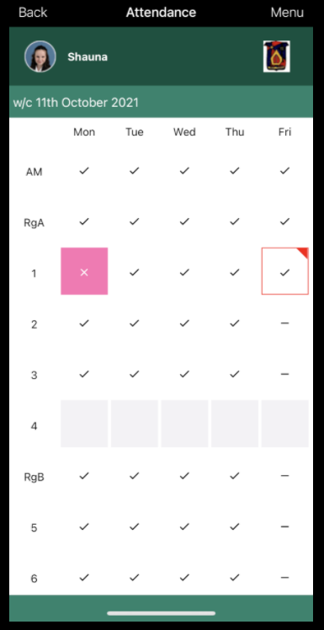
The parent can click this period to see the information. To demonstrate this procedure, a student was selected (permission approved). Information was added to the pupil’s Maths lesson indicating that she was 10 minutes late and left the class to visit the toilet.

In advance of return to school on 1st November 2021, Lesson Monitor was swtiched on via ParentApp. The image on the left shows what parents will see when it is open.
As you can see Period 1 on Friday is highlighted in red which indicates that there is other information about that lesson.

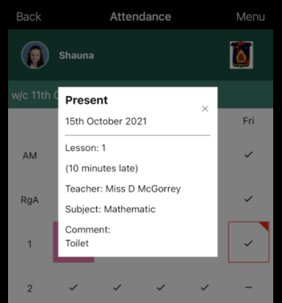
SLT will continue to monitor the toilets at the beginning/end of the lesson to prevent large numbers congregating and being late to class.
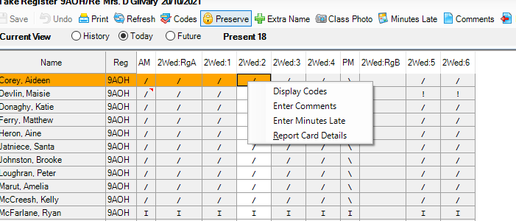
To add minutes late or any comment about the lesson – Right Click on the period you have the pupil and add to ‘Enter Minutes Late’ and/or ‘Enter Comments.’ Ok and Save.

SCHOOL TOILET POLICY

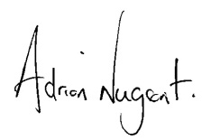

Signed …………………………………………… (Chairman of Board of Governors)

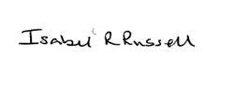
Signed ……………………………………………. (Principal)

Date: 1 May 2022

Board of Governors Meeting held on 6 October 2022

Next Review Date: September 2023

