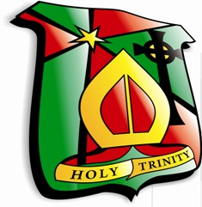 Holy Trinity College
- Test yourself on these misspelled words in the English language. Practice makes perfect…

