Appendix to the Positive Behaviour for Learning Policy – COVID 19
This appendix will remain in place until COVID 19 is no longer seen as a threat by the Government. It will be subject to review and potential amendments if and when the Government guidance changes.
The staff of Holy Trinity College are committed to providing the best possible educational opportunities for our pupils. We aim to create and maintain a caring and supportive environment in which they will flourish academically, socially and emotionally, and in which they will develop into independent and self-motivated young people.
Within the context of the general aims, we expect all pupils to behave in a positive and responsible manner. Positive behaviour is encouraged and rewarded through praise and public acknowledgement. We value self-discipline and we encourage pupils to think carefully about the consequences of their actions.
In cases where our pupils’ behaviour does not meet the high standards expected, a framework exists in which they are given the opportunity to consider and reflect on their behaviour. A clear sequence of sanctions is also in place to reinforce, where necessary, the need for positive behaviour.

Policy in practice COVID 19
When our pupils return, classroom principles will be shared with them, within the context of the present situation and keeping all pupils and staff safe. These principles include
- Politeness and consideration towards each other and to adults
- Respect for each other’s and school property
- Developing a positive working environment
- Understanding the importance of social distancing and personal hygiene
Guidelines re. appropriate behaviour will be displayed in the classroom, corridors and discussed on a regular basis. Guidelines will be phrased in positive rather than negative terms.
Pupils will have to follow additional rules during this period.
- Pupils will follow altered routines for arrival and departure to school and during the school day
- Pupils will follow instructions and routines for hygiene, hand-washing when asked by the staff, sanitising on entry to the school
- Pupils will follow instructions on where they should go in school and endeavour not to go beyond the permitted areas.
- Pupils will walk in orderly lines respecting social distancing
- Pupils will follow clearly set out expectations for sneezing, coughing, use of tissues and their disposal
- Pupils will inform staff if they think that they have symptoms of the COVID-19. The parents/guardians of any pupil displaying symptoms will be contacted to be sent home. Until they can be collected from school, the pupil will be isolated in a dedicated room near the front office.
- Pupils will abide by the rules about not sharing equipment
- Pupils will follow new guidance for break-time and lunch-time and remain in the designated areas
- Pupils will not cough in anyone’s face or toward anyone. Pupils may not spit
- Pupils must show respect for and follow instructions of staff to ensure their well-being and safety at all times.

Categories of recommended and enabling behaviours to reduce COVID-19 transmission

Categories of recommended behaviours

- Maintaining hygiene

- Cleaning hands | - Pupils will have access to soap and water and sanitiser at all time. Pupil may carry their own personal sanitisers.  - Wash hands effectively for 20 seconds, soaping backs of your hands, between your fingers and under your nails.
- Using and disposing of tissues  ‘Catch it – Bin it – Kill it | - Make sure you have clean tissues available.  - Dispose of tissues immediately in the plastic-lined bins covered with lids  - Train yourself to cough or sneeze into tissues (or the crook of your elbow, if not available), not your hands.
- Avoiding touching
- Avoid unnecessary touching | - Avoid touching nose, mouth and eyes  - Avoid close contact greetings – e.g. hugging or shaking hands
- Avoid touching surfaces | - Avoid touching surfaces at risk of contamination e.g. the walls of the corridors, stair rails etc  - Do not handle other pupils’ personal objects e.g. mobile phones
- Social Distancing
- Maintain personal distance | - Do not stand or sit close to another pupil or a member of staff – be respectful of the 2 metres distance from staff.
- Avoid Crowds | - Avoid physical gatherings  - Abide by the one-way system at all times  - Follow the directions of staff when entering and leaving school, walking on the corridor and entering and exiting the rooms or canteen

Aspects of behaviour that are agreed as being unacceptable will include:
- Physical aggression, violence, hitting or hitting back
- Intentionally coughing and spitting at any other person
- Deliberately using other people’s resources and materials
As well as understanding the guidelines that have been established and agreeing to them, it is also important that children understand the consequences of their behaviour, for themselves and for others.

If a pupil deliberately shows disrespect for another person’s health and safety during this time by breaking any of these guidelines, they are putting others at risk. Any pupil who commits a serious, or persistent breach of the new COVID-19 protection rules will be sanctioned using the full range of sanctions available, dependent on the seriousness of the breach, up to and including exclusion from school. Pupils who deliberately put others at risk will be subject to a risk assessment regarding their on-site attendance.
Due to these exceptional circumstances, and the need to ensure a safe environment for our school community, there may be behaviour issues which warrant immediate action (where warnings, reflection and time for modification of behaviour might normally be our practice), where following a risk assessment, such action is deemed necessary due to the immediate threat to the health of pupils and staff in the school and their families.
Pupils are expected to follow social distancing and hygiene protocols that have been implemented by the school under the guidance of the Public Health Authority. These regulations are in place in order to keep our school community and their families safe.

As a result of the potential seriousness of a breach of these regulations, severe sanctions have been put in place to protect the pupils and staff of Holy Trinity College.
- Failure to comply with Social Distancing and Hygiene protocols will result in contact with home.
- Repeated failure to comply will lead to a one- day suspension being issued and the child, on return to school, will be subject to a Risk Assessment regarding their on-site attendance.
- Reckless and deliberate behaviour may result in exclusion because of the immediate threat it presents to the health and wellbeing of the pupils and staff.

Positive Behaviour when using the Zoom Classroom
In the event that your teacher uses Zoom as a tool for Distance Learning, it is essential that you follow the guidelines in this virtual classroom in the same way as you maintain standards of behaviour in the physical classroom.
- Log into your meeting from a distraction free, quiet environment after informing your parent/guardian of your attendance in the Zoom classroom. Wear suitable clothing in the virtual classroom.

- Keep your audio on mute until you want to speak. This will help limit background noise.

- Follow your teacher’s instructions regarding switching on or off your video feed.

- If you want to speak or answer a question, use the ‘Raise hand’ feature. Then unmute yourself after you are called on.

- If you would like to use the chat box, remember that it is public and a record of the chat is kept and archived. (Teachers may switch chat off).

- Have paper and a pen/pencil to take notes.

- Do not share the meeting ID or password with others. Your teacher will share these details with the pupils invited to participate in the virtual lesson through their c2k email.

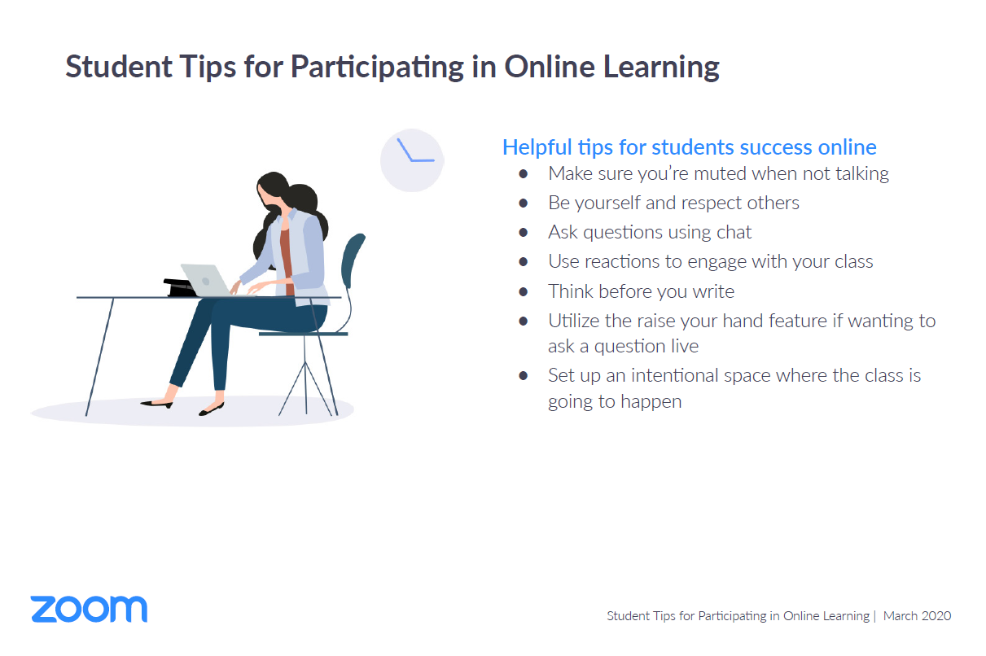

In the event of inappropriate behaviour during a Zoom or any virtual classroom, your teacher will remove you as a participant in the virtual classroom and refer the behaviour to the Head of Year. Any manipulation and circulation of a teacher’s or another pupil’s image collected from a virtual meeting organised by the staff to facilitate learning will result in referral to the Principal. The Principal and The Board of Governors reserve the right to insist that any footage known to have been recorded on school premises or during a virtual lesson will be deleted before the confiscated device is returned. This point is linked to the school’s Child Protection/Acceptable Use Policy. Depending on the seriousness of the incident, procedures in line with the E-Safety Policy may also follow, resulting in further sanctions being applied.

It should be noted that it is a criminal offence to use a mobile phone to menace, bully or offend another person. Almost all calls, text messages and emails can be traced by the PSNI.

