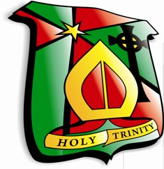 Holy Trinity College
- Test yourself on these misspelled words in the English language – very useful for GCSE Preparation!

a lot | accidentally | are/our
believe | chose/choose | definitely
difference | embarrass | environment
especially | excitement | exclamation mark
exercise | form/from | happened
humour/humorous | information | interesting
lose/loose | maybe | necessary
of/off | opinion | opportunity
perform | principal/principle | professional
quite/quiet | right/write | receive
statistics | successful | surely
their/there/they’re | though/thought | threw/through
to/too/two | where/were/we’re | your/you’re

