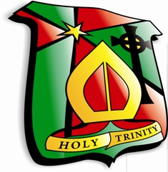 Holy Trinity College
Suggestions for Summer Reading
- Skellig – David Almond
- Alice in Wonderland – Lewis Carroll
- How to Train Your Dragon – Cressida Cowell
- Northern Lights – Phillip Pullman
- Silverfin – Charlie Higson
- Wonder – R. J. Palacio
- Percy Jackson and the Lightning Thief – Rick Riordan
- Boy – Roald Dhal
- The Lion, The Witch, The Wardrobe – C.S Lewis
- War Horse – Michael Morpurgo
- Diary of a Wimpy Kid – Jeff Kinney
- Artemis Fowl – Eoin Colfer
- Billionaire Boy – David Walliams
- I am Malala – Malala Yousafzai

PS. Check out www.lovereading4kids.co.uk. Don’t forget to write your blurb for your Summer Reading Challenge!

