Free School Meals Payment - Important Notice

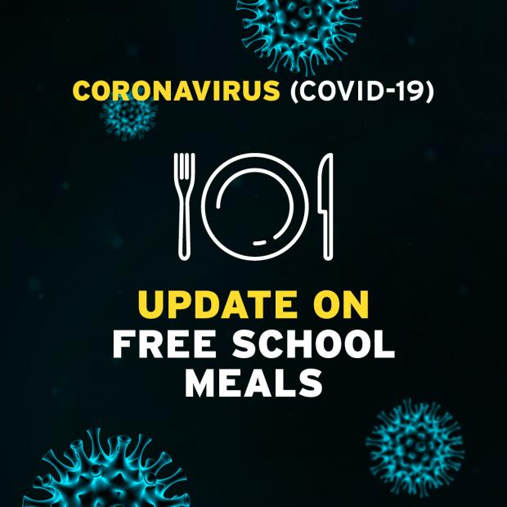

As a result of school closures due to the Coronavirus outbreak, both the Minister for Education and the Minister for Communities, have agreed to make direct payment to families who have been assessed as eligible for free school meals. A total of £2.70 per child per day, will be paid to families on a fortnightly basis, for each day that schools are closed during term time. All payment will be under the guidance of the Education Authority, who already have details for the vast majority of those in receipt of free school meals. Further details can be found at www.eani.org.uk within the section COVID-19 Free School Meals.

