

* **I have a concern about my child’s safety**
* **I can talk to the Form Teacher/Head of Year/Head of Key Stage/Pastoral Support Officer**
* **If I am still concerned I can talk to the DT/DDT Mrs Quinn, Mrs Tracey, Mrs Skelton-McKenna or Miss McAlinden**
* **If I am still concerned I can talk to the Principal Mrs Russell**
* **If I am concerned I can talk/write to the Board of Governors**
* **I can contact NI Public Services Ombudsman on 0800 343 424**
* **At any time I can talk to local Children’s Services Gateway Team on 79 65 1020 or PSNI Central Referral Unit on 028 9025 9299**

**How can parents/guardians get help?**

* **I am worried that something is happening to me or someone I know and I need help**
* **I can talk to my Form Teacher, Head of Year, Pastoral Support Officer or Head of Key Stage**
* **I can talk to the DT/DDT Mrs Quinn, Mrs Tracey, Mrs Skelton-McKenna or Miss McAlinden**
* **I can talk to Mrs Russell the Principal**

**POLICY STATEMENT**

At Holy Trinity College we have a primary responsibility for the care, welfare and safety of the pupils in our charge and we will carry out this duty through our policy which aims to provide a caring, supportive and safe environment. A copy of our Safeguarding and Child Protection Policy is available to download from [www.holytrinitycollege.org](http://www.holytrinitycollege.org)

**How can pupils get help?**

**CHILD PROTECTION**

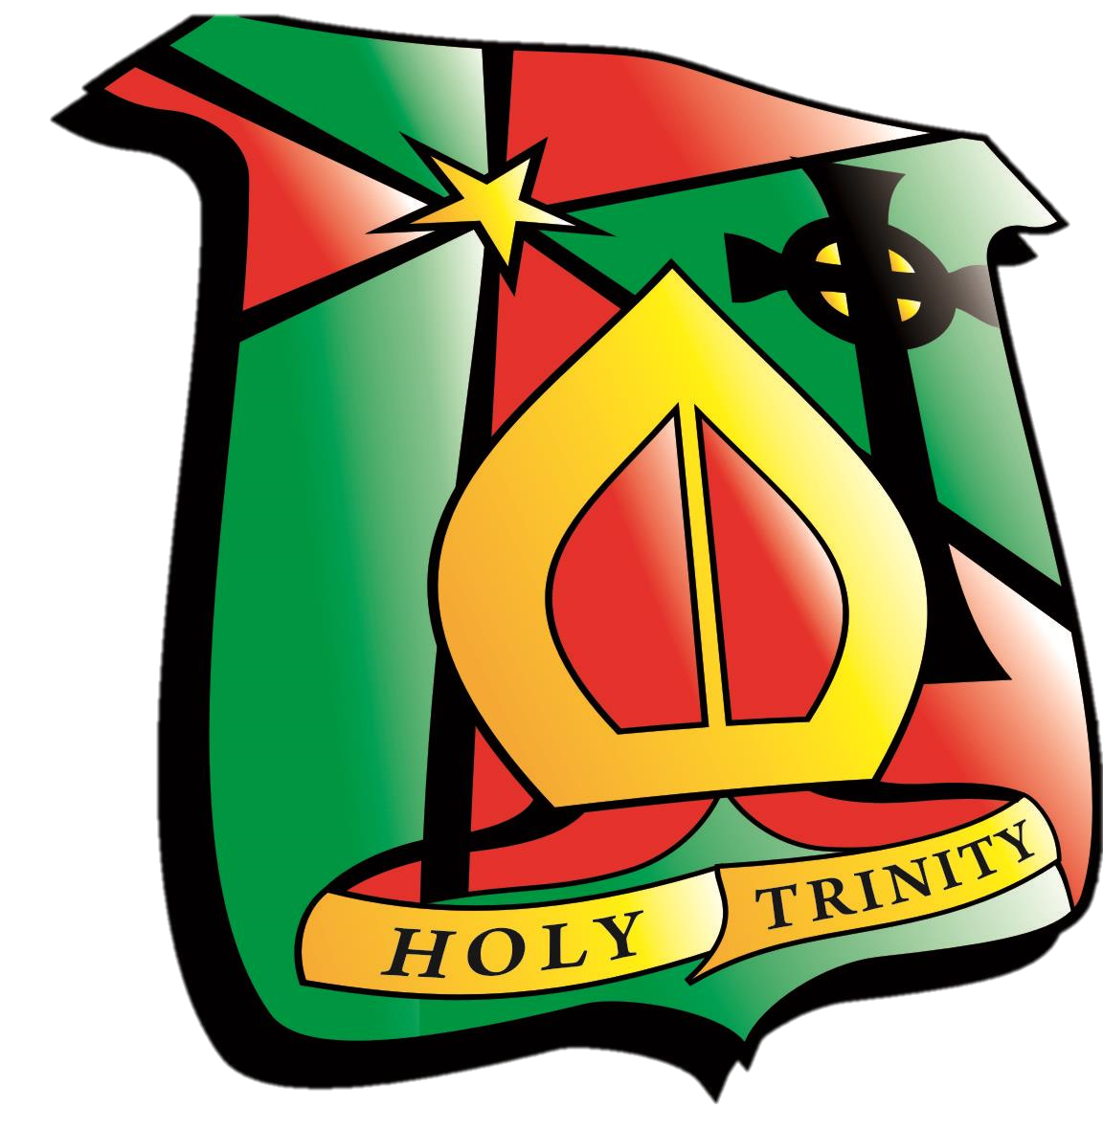

**If you have a concern, what do you do?**